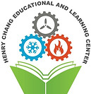
The Henry Chang Learning Center
Engineers Education & Opportunities Foundation
31 Chambers ST, NY. NY. 10007

CLASS APPLICATION
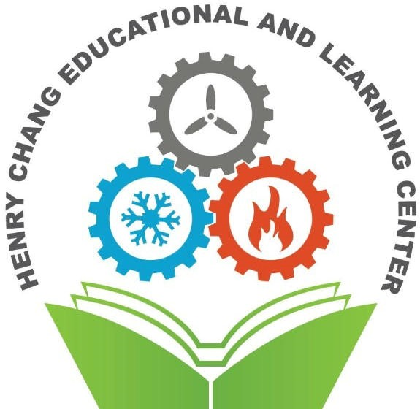
Please Circle the Class you are interested in:

Refrigeration / HVAC Split Units
Welding
Pneumatics

Name: _________________________________________
Phone Number: _________________________________________
Email address: _________________________________________
Work Address: _________________________________________
Civil Service Title: ________________________________________
Do you have a Refrigeration License? ____________________________
Do you have a High-Pressure Steam License? ____________________________
Will you have any issues attending classes on a Friday from 9am – 12pm? ___________
The Henry Chang Education and Learning Center is run by a committee that volunteer their time to teaching and running fund raisers that finance the purchasing of material and equipment. We currently have simulators for the following equipment:
Refrigeration units; Heat pumps: Air Handling Unit with controls: Desk top refrigeration unit that shows state of refrigerant. Control panel for high and low voltage wiring
Please fill out the application and email to: ddonovan@dcas.nyc.gov

